Don't Dream It's Over – Crowded House

NB: CAPO op 1e fret, of alle snaren een halve toon hoger stemmen als je met de CD wilt meespelen.

Accoord diagrammen:

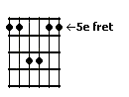 | 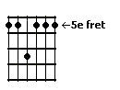 | 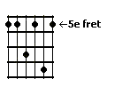 | 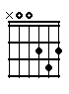
Dadd9 | D9 | D11 | D

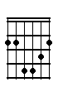 | 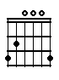 | 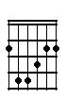 | 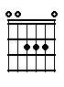 | 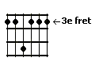
Bm | G | Fis | A | C9

Intro:

Dadd9 | D9 | D11 | 2x

Couplet:

Dadd9 | Bm | G | Fis
There is freedom within, | there is freedom without | Try to catch the deluge in a paper | cup
There's a battle ahead, | many battles are lost | But you'll never see the end of the road while you're | traveling with me

Refrein:

G | A | D | Bm
Hey now, | hey now, don't | dream it's | over
Hey now, | hey now | When the world comes | in
They come, | they come | To build a wall be- | tween us

G | A
We know they won't win ………

Couplet:

Dadd9 | Bm | G | Fis
Now I'm towing my car, | there's a hole in the roof | My possessions are causing me suspicion but | there's no proof
In the paper today | tales of war and of waste | But you turn right over to the T.V. | page

Refrein:

G | A | D | Bm
Hey now, | hey now, don't | dream it's | over
Hey now, | hey now | When the world comes | in
They come, | they come | To build a wall be- | tween us

G
We know they won't win

Tussenspel:

D | Bm | G | Fis | 2x

G | D | 3x

C9

Couplet:

Dadd9 | Bm | G | Fis
Now I'm walking again | to the beat of a drum | And I'm counting the steps to the door of your | heart
Only shadows ahead | barely clearing the roof | Get to know the feeling of liberation and | relief

Refrein:

G | A | D | Bm
Hey now, | hey now, don't | dream it's | over
Hey now, | hey now | When the world comes | in
They come, | they come | To build a wall be- | tween us

G
We know they won't win

G | A | D | Bm
-- | -- | -- | Don’t let them
win; hey now, | hey now | -- | --
Hey now, | hey now | -- | --
Hey now, | hey now | -- | don’t let them
win; | -- | -- | don’t let them
win; hey now, | hey now | -- | --
Hey now, | hey now, | -- | --

