Don't Let It Bring You Down - Annie Lennox

from the album: “Medusa”
(original by Neil Young)

CAPO: 3e fret

Accoorden:

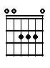 | 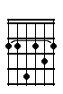 | 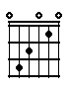 | 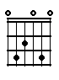
A | Bm7 | C | Cadd9

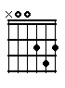 | 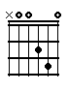 | 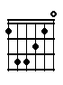 | 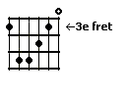
D | Dadd9 | Fmaj7 | G6

Song:

A | C | A | Cadd9 | 2x

Intro

A | C
Old man lying by the side of the road, with the | lorries rolling by

Dadd9 | Fmaj7 | G6
Blue moon sinking from the weight of the load, and the | building scrape the | sky

A | C
Cold wind ripping down the alley at dawn, and the | morning paper flies

Dadd9 | Fmaj7 | G6
Dead man lying by the side of the road, with the | daylight in his | eyes. Don't let it bring you

D | C | Bm7
down, it's only castles | burning, find someone who's | turning and you will come a-

A | C | A | Cadd9 | 2x
round

A | C
Blind man running through the light of the night, with an | answer in his hand

Dadd9 | Fmaj7 | G6
Come on down to the river of sight, and you can | really under- | stand

A | C
Red lights flashing through the window in the rain, can you | hear the sirens moan?

Dadd9 | Fmaj7 | G6
White cane lying in a gutter in the lane, if you're | walking home a- | lone. Don't let it bring you

D | C | Bm7
down, it's only castles | burning, find someone who's | turning and you will come a-

A | C | A | Cadd9 | 2x
round

A | D | Bm7
Don't let it bring you down, it's only castles | burning, find someone who's | turning and you will come a-

A | C | A | Cadd9 | 2x
round

A | C
Old man lying by the side of the road, with the | lorries rolling by

Dadd9 | Fmaj7 | G6
Blue moon sinking from the weight of the load, and the | building scrape the | sky

A | C
Cold wind ripping down the alley at dawn, and the | morning paper flies

Dadd9 | Fmaj7 | G6
Dead man lying by the side of the road, with the | daylight in his | eyes. Don't let it bring you

D | C | Bm7
down, it's only castles | burning, find someone who's | turning and you will come a-

A | C | A | Cadd9
round

A | D
Don't let it bring you down, it's only castles | burning, find someone who's

Bm7 | A
turning and you will come a- | round

