Galadriel - Barclay James Harvest

Accoord diagrammen:

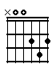 | 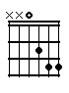 | 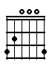 | 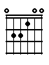 | 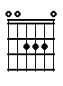
D | Dsus4 | G | E | A

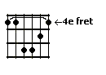 | 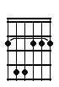 | 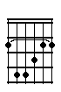 | 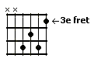 | 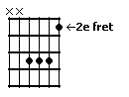
Cism | Fism | Fis | Em | B

Song:

D (sus4) | G | D
intro

D | E | A
She comes up | with the morning | sun, and tells me life has just be-

D | Cism | Fism | G
gun | oh what it is to be | young

D | E | A
And in the | early morning | light, she brings me flowers from the

D(sus4) | Cism | Fis | Em | B
sun | oh what it is to be | young And if you

Em | B | Em | E | Fis
see her you will | know, she is like a | shadow passing | softly on the | snow

D | E | A
And in the | early evening | light, she brings me flowers for the

D(sus4) | Cism | Fism | G
night | oh what it is to be | young

D | E | A | D(sus4) | Cism | Fism
intermezzo

D | E | A | D(sus4) | Cism | Fis | Em | B
intermezzo And if you

Em | B | Em | E | Fis
see her you will | know, she is like a | shadow passing | softly on the | snow

D | E | A
And in the | early evening | light, she brings me flowers for the

D(sus4) | Cism | Fism | G
night | oh what it is to be | young

D (sus4) | G | D(sus4)
end

