Nothing Else Matters - Metallica

Chords:

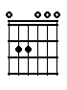 | 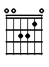 | 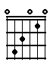 | 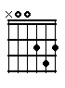 | 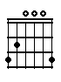 | 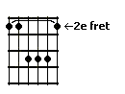 | 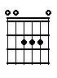
Em | Am | C | D | G | B | A

Song:

Em | Em | Em | Em | Am | C | D | Em | Em
intro

Em | D | C | 3x
intro

G | B | Em
intro

I
Em | D | C
So close no matter | how far
Couldn't be much more | from the heart
Forever trusting | who we are

G | B | Em
And | nothing else | matters

II
Em | D | C
Never opened my- | self this way
Life is ours, we live it | our way
All these words I don't | just say

G | B | Em
And | nothing else | matters

III
Em | D | C
Trust I seek and I | find in you
Every day for us | something new
Open mind for a | different view

G | B | Em
And | nothing else | matters

IV
C | A | D
 |  | Never cared for what they
do. |  | Never cared for what they

C | A | D | Em
know. |  | But I | know

Repeat: I, IV

Em | Am | C | D | Em | 2x

Intermezzo

Repeat: II, III

C | A | D
 |  | Never cared for what they
say. |  | Never cared for games they
play. |  | Never cared for what they
do. |  | Never cared for what they

C | A | D | Em
know. |  | But I | know

Em | D | C | 3x
solo

G | B | Em
solo

Repeat: I

