Sacrifice - Anouk

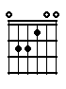 | 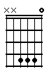 | 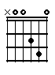 | 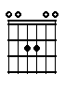
E | B_add11 | D_add9 | A_add9

INTRO

E | B_add11 | D_add9 | A_add9
Who's the one that makes you  Who's the reason you're  I was the one that made you  But I'm the reason that you're | happy  smiling  happy  crying now | Who's the one that always makes you  And dragged you through these time, so  I was the one that eased the  My own tears scattered by the | laugh  rough  pain  rain

 |  |  | 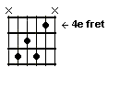
E | B_add11 | D_add9 | Dis7
You can sacrifice | me | You can sacrifice | me

E | B_add11 | D_add9 | A_add9
You can set me | free | You can be who you wanna | be

Tussenspel: E - B_add11 - D_add9 - A_add9

E | B_add11 | D_add9 | A_add9
Deeper than deep you took me on a  You dare me to express my feelings  But suddenly you needed  You started drowning in your | trip baby  to you  freedom  sorrow | You shared your wildest dreams and  I never felt that need be-  You felt the need to break  You didn't wanna know I had the | more  fore  free  key

E | B_add11 | D_add9 | A_add9
You can sacrifice  You can set me  You can set me | me  free  free | You can sacrifice  You can be who you wanna  You can be who you wanna to | me  be  be

E | B_add11 | D_add9 | A_add9 | E
You can sacrifice me, | sacrifice me | You can be who  you wanna | You can be who  you wanna | be

