Spanish Guitar - Toni Braxton

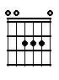 | 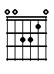 | 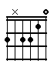 | 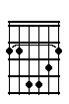 | 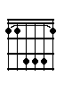 | 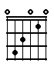
A | Am | Am/Fis | Bm | Bes | C

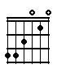 | 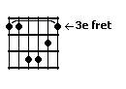 | 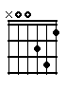 | 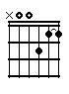 | 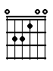
C/G | Cm | Dm | Dm7 | E

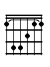 | 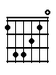 | 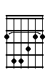 | 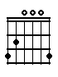 | 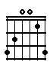
F | Fmaj7 | Fis | G | Gsus4

Intro:

Dm | Gsus4 | G | Am | G

Intro

Couplet:

F | E | Am
A smoky | room, a small ca- | fé; They come to hear you

C/G | F
play, and drink and dance the | night away

Bm | E | A | Fis
I sit | out in the crowd, and | close my eyes, | dream you're mine, but

Bm | E | A
you don't know, you | don't even know that | I’m there; I wish that

Refrein:

Dm | G | C | Em
I was in your | arms, like that | Spanish gui- | tar, and you would

Dm | G | A
play me through the | night, till the | dawn; I wish you'd

Dm | G | C | Em
hold me in your | arms, like that | Spanish gui- | tar, all night

Am/Fis | Fmaj7 | Em
long, all night long, all night | long, all night long, I'd be your | song, I'd be your ..

Couplet:

F | E | Am
..song; Steal my heart with | every note you | play; I pray you'll look my

C/G | F
way, and hold me to your | heart someday

Bm | E | A | Fis
I long to | be the one that | you caress with | tenderness, and

Bm | E | A
you don't know, you | don't even know that | I exist ……; I wish that

Refrein:

Dm | G | C | Em
I was in your | arms, like that | Spanish gui- | tar, and you would

Dm | G | A
play me through the | night, till the | dawn; I wish you'd

Dm | G | C | Em
hold me in your | arms, like that | Spanish gui- | tar, all night

Am/Fis | Fmaj7 | Em
long, all night long, all night | long, all night long, I'd be your | song, I'd be your song

Intermezzo / solo:

Cm | F | Bes | G
 | Te sientas entre la gente | Cierras tu | ojos

Cm | F | G
Y suenas que soy | tuyo | Pero yo no siquiera se que estas ahi

Cm | Bes | G
Me gustaria tenerte entre mis brazos | amor | … I sit

E | A | Fis
out in the crowd, and | close my eyes, | dream you're mine, and

Bm | E | A
you don't know, you | don't even know that | I exist …….; I wish that

Refrein:

Dm | G | C | Em
I was in your | arms, like that | Spanish gui- | tar, and you would

Dm | G | A
play me through the | night, till the | dawn; I wish you'd

Dm | G | C | Em
hold me in your | arms, like that | Spanish gui- | tar,

Dm | G | C | Em
…….. | ……, like that | Spanish gui- | tar, all night

Am/Fis | Fmaj7 | Em
long, all night long, all night | long, all night long, I'd be your | song, I'd be your song,……… I'd be your

Dm7 | G | Am | C/G
song, your song, your | song, I'd be your | song yeah, | …………… I'd be your

Dm7 | G | Am | C/G
song, your song, your | song, all night | long | yeah..…… I'd be your

Dm7 | G | Am | C/G | 6x
song, your song, your | song, I'd be your | song yeah, | …………… I'd be your | fade-out

