Thank You For Loving Me – Bon Jovi

ACCOORD DIAGRAMMEN:

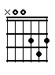 | 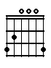 | 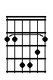 | 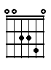 | 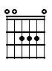
D | G | Bm | Asus4 | A

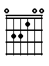 | 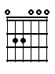 | 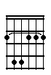 | 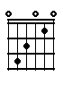
E | Em | Fism | C

SONG / ACCOORDEN:

D | G | Bm | Asus4 | A | 2x

Intro

Couplet:

G | D
It's hard for me to say the things I | want to say sometimes

G | D
There's no one here but you and me, and that | broken old street light

Bm | G | A
Lock the doors, we'll | leave the world out- | side

D | G | A
All I've got to | give to you are | these five words when I thank

Refrein:

D | G | A | D
you for loving | me for being my | eyes when | I couldn't see, for parting

Bm | E | A
my lips, when I couldn't | breathe ………. thank

D | G | A | D | G | Asus4 | A
you for | loving | me, thank | you for | loving | me

Couplet:

G | D
I never knew I had a dream un- | til that dream was you

G | D
When I look into your eyes, the | sky's a different blue; cross my

Bm | G | A
heart | I wear no dis- | guise

D | G | A
If I tried, you'd | make believe that | you believed my lies, thank

Refrein:

D | G | A | D
you for loving | me for being my | eyes when | I couldn't see, for parting

Bm | E | A
my lips, when I couldn't | breathe ………. thank

D | G | A
you for | loving | me

Intermezzo:

G | A
You pick me up when I fall down | You ring the bell before they count me out

Em | Fism | G
If I was drowning you would | part the | sea

C | D | G | A
And risk your own life to | rescue | me

D | G | A | D

Solo

Bm | G | A
Lock the doors, we'll | leave the world out- | side

D | G | C | A
All I've got to | give to you are | these five words when | I thank
Refrein:

D | G | A | D
you for loving | me for being my | eyes when | I couldn't see, for parting

Bm | E | A
my lips, when I couldn't | breathe ……… thank

D | G | A | D
you for loving | me, when I couldn't | fly, oh, | you gave me wings, you parted

Bm | E | A
my lips, when I couldn't | breathe ……… thank

D | G | A | D | G | A | D | G | Asus4 | A
you for | loving | me, thank | you for | loving | me, thank | you for | loving | me

D | G | Bm | Asus4 | A | 2x

slotmelodie

D
einde

