Whole Again - Atomic Kitten

Accoorden:

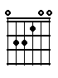 | 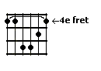 | 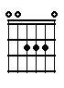 | 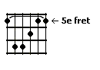 | 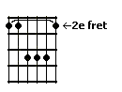 | 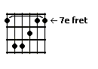
E | C#m | A | A (alternatief) | B | B (alternatief)

Couplet:

E | C#m
If you see me walking down the street staring at the | sky and dragging my two feet, you just pass me

A | B | E | B
by, it still makes me | cry, but you can make me | whole again

E | C#m
And if you see me with another man, laughing and jo- | king, doing what I can, won't put you

A | B | E | B
down, 'cos I want you a- | round, you can make me | whole again

Refrein:

E | B
Looking back on when we first met, I cannot escape and | I cannot forget, baby you're the

A | B | E | B
one, you still turn me | on, you can make me | whole again

Couplet:

E | C#m
Time is laying heavy on my heart, seems I've got too | much of it, since we've been apart, my friends make me

A | B | E | B
smile, if only for a | while, you can make me | whole again

Refrein:

E | B
Looking back on when we first met, I cannot escape and | I cannot forget, baby you're the

A | B | E | B
one, you still turn me | on, you can make me | whole again

Intermezzo:

A | B | A | B
For now I'll have to wait, but baby if you change your | mind, don't be too late 'cos | I just | can't go

A | B | E | B
on, it's already been too | long, but you can make me | whole again | oh, woah, woah, woah

Refrein (3x):

E | B
Looking back on when we first met, I cannot escape and | I cannot forget, baby you're the

A | B | E | B
one, you still turn me | on, you can make me | whole again | oh, woah

