You – Judith

Accoorden schema’s:

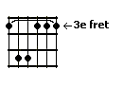 | 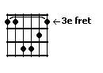 | 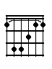 | 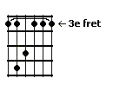 | 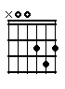
Gm | Cm | F | Esmaj7 | D

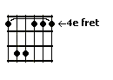 | 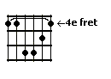 | 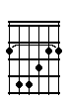 | 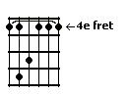 | 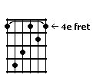
Gism | Cism | Fis | Emaj7 | Dis = Es

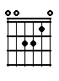 | 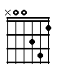 | 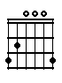 | 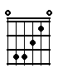 |  | 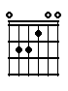
Am | Dm | G | Fmaj7 | F | E

Tekst / accoorden:

Gm | Cm
You see me as the girl next-door, like you | know so many, many more

F | Cm | F | Cm
Just a fish that | swims in | your direction, and could | bring love and af-

Gm | Esmaj7 | D
fection …………………………….. |  |  | But I can't

Gm | Es | F
play the came of love with you | I know it will only | hurt me, I

Cm | D
feel the tears in my eyes | because we have to say goodbye

Gm | Es | F
Looking in the face of love | I’ll never | touch it

Cm | D | Gm
It will be self-deceit, to | think you would stay with | me

Gism | Cism
You think you mean the same to me, but I'm af- | raid and to shy to let you see

Fis | Cism | Fis | Cism
To me you're really someone | special, I | found in me the learn to | haste it, I feel

Gism | Emaj7 | Dis
love is bad …………………….. |  |  | But I can't

Gism | E | Fis
play the came of love with you | I know it will only | hurt me, I

Cism | Dis
feel the tears in my eyes | because we have to say goodbye

Gism | E | Fis
Looking in the face of love | I’ll never | touch it

Cism | Dis | Gism
It will be self-deceit, to | think that you would never leave ……….

Am | Dm
Blisters on my soul, are they my | paths, or are they a goal, cause

G | Dm | G | Dm
everytime I feel | love, | faith really breaks it | up, will it ever

Am | Fmaj7 | E
stop ………………………………….? |  |  | But I can't

Am | F | G
play the game of love with you | I know it will only | hurt me, I

Dm | E
feel the tears in my eyes | because we have to say goodbye

Am | F | G
Looking in the face of love | I’ll never | touch it

Dm | E | Am
It will be self-deceit, to | think that you would never leave ………..

